

Practices for Secure Software Report

Table of Contents
Document Revision History 3
Client 3
Instructions 3
Developer 4
1. Algorithm Cipher 4
2. Certificate Generation 4
3. Deploy Cipher 4
4. Secure Communications 4
5. Secondary Testing 4
6. Functional Testing 4
7. Summary 4
8. Industry Standard Best Practices 4

Document Revision History

Version | Date | Author | Comments
1.0 |  | Mitchell Ramirez | First Draft

Client



Instructions

Submit this completed practices for secure software report. Replace the bracketed text with the relevant information. You must document your process for writing secure communications and refactoring code that complies with software security testing protocols.

- Respond to the steps outlined below and include your findings.
- Respond using your own words. You may also choose to include images or supporting materials. If you include them, make certain to insert them in all the relevant locations in the document.
- Refer to the Project Two Guidelines and Rubric for more detailed instructions about each section of the template.

Developer
Mitchell Ramirez

Algorithm Cipher

When at rest, Artemis’ data needs to be encrypted and always protected. I previously stated that the nature of the financial sector is that data becomes an appealing target. For securing this data, I would suggest encrypting the data in AES-128 that is being utilized with CTR mode enabled. Although AES is a symmetric encryption which means that the keys need to be secured and employing RSA for this would be beneficial since it is the best of both worlds.

By choosing this scheme, it gives Artemis the speed of AES while having the security of RSA because we do not need to rely on asynchronous keys with RSA and having slowdowns of performance. Implementing both is not really a challenge for most companies where they can include both without any worries. Including both gives the company great security by protecting the vulnerable part (symmetrical keys from AES) while having a very rigid encryption schematic; all while not subjecting the users with the slow performance of RSA (having the asymmetrical key).

Furthermore, I would choose AES-128 utilizing the CTR method. CTR is advantageous by being able to include parallel encryption and decryption. If there is a large body of encrypted data, this would satisfy the users. On top of that, CTR since it is newer than the older methods such as DES and 3DES. ECB should not be used for any data larger than 128-bits because of having repeating patterns becoming obvious to attackers.

Lastly, AES-128 is suggested over AES-256 for performance reasons because it should enough for mostly every case of security minus the usage of quantum computing.

Certificate Generation
Insert a screenshot below of the CER file.

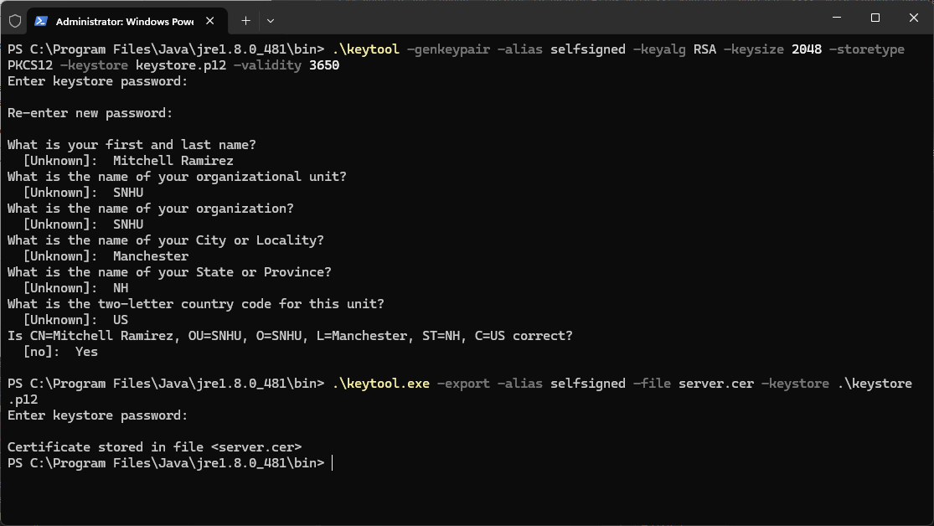
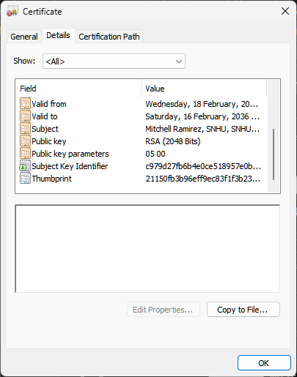

Deploy Cipher
Insert a screenshot below of the checksum verification.

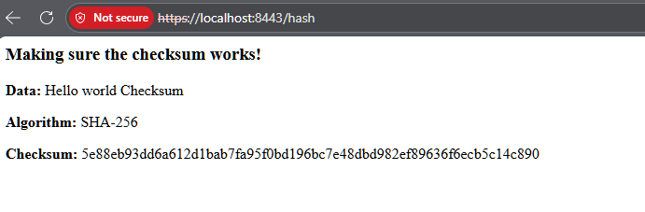

Secure Communications
Insert a screenshot below of the web browser that shows a secure webpage.
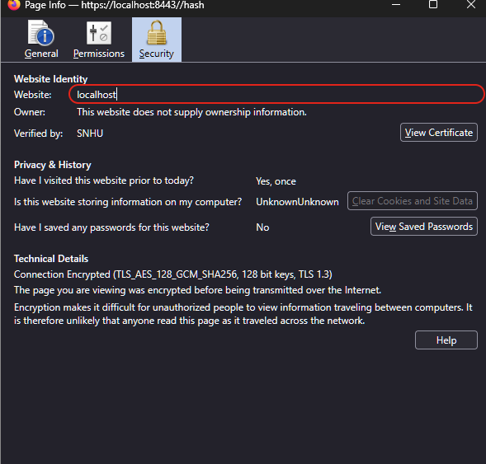

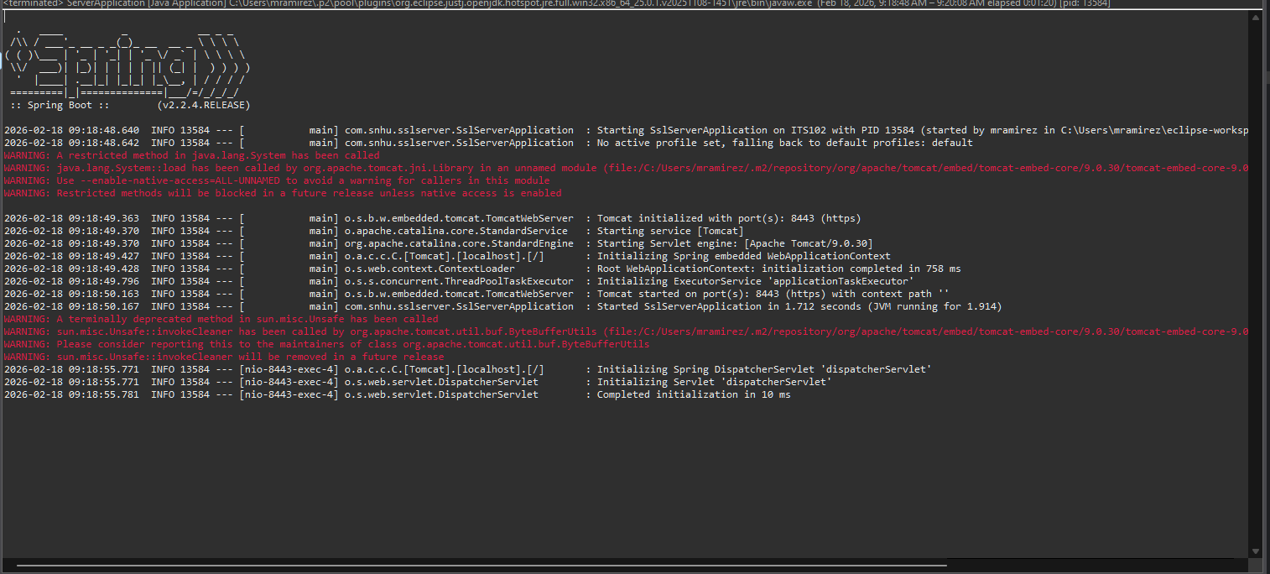

Secondary Testing
Insert screenshots below of the refactored code executed without errors and the dependency-check report.

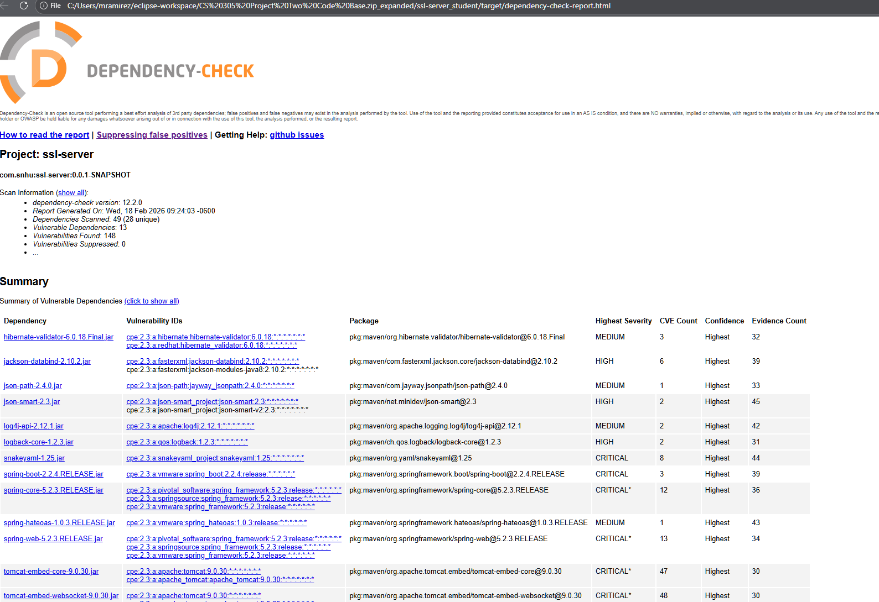

Functional Testing
Insert a screenshot below of the refactored code executed without errors.

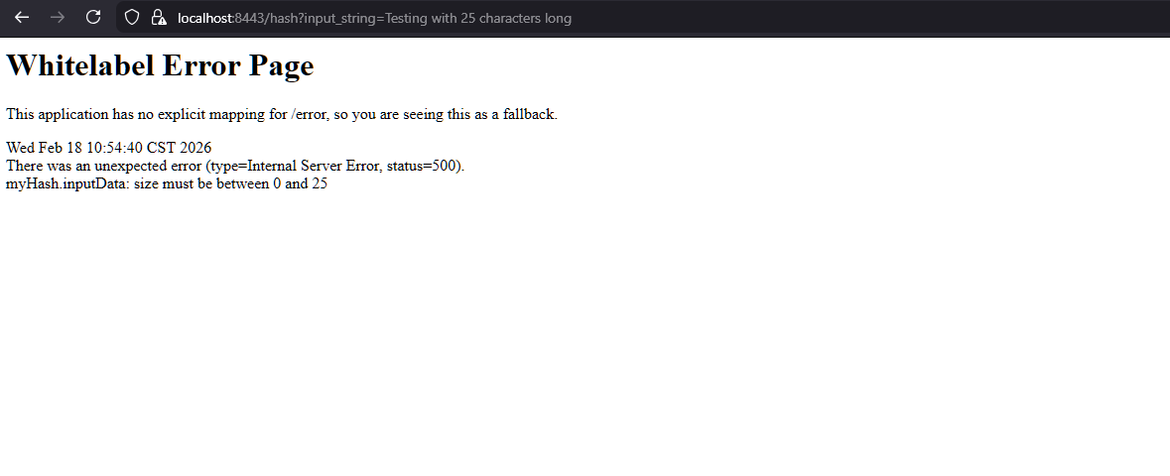

Summary
The code was then refactored, so that the traffic to the website was sent over HTTPS. By enabling HTTPS, the website prevented us from having the information broadcast to anyone that was to spy on the network. The HTTPS communication was secured by using AES-128 and then using a selfsigned certificate. This will need to be eventually changed to use a public trusted CA root-type certificate such as LetsEncrypt or ZeroSSL.

The API that was created has been designed to return the checksum of a string that is provided. The checksum may be used to check the fingerprints of a digital object. I pushed the object through the hashing and then the hash was generated. A well-designed hash will have no collisions: two dissimilar digital objects cannot produce the same hash. So the hash allows someone else to validate if the file they received has been manipulated in any way. The checksum was generated by using SHA-256 which has a probability of two hashes that were to be colliding would be approximately 4.3*10^-60. With other hashing functions such as MD5, SHA-0, and SHA-1, they were all found to have collisions.

By having any collisions, this would allow someone outside of the network to spoof a checksum or reverse engineer the original file.

Industry Standard Best Practices
By following the OWASP practices, they state that “[t]he goal of software security is to maintain the confidentiality, integrity, and availability of information resources in order to enable successful business operations.” There is a difference between the developer and the attacker: the developer approaches the application based on what it is intended to do; the attacker has their eyes on how the application can be made to do and how it can operate, which states that “any action not specifically denied, is allowed.” Thus, giving the attacker any way on how to break the software and make it work outside of its intended parameters.

The value of applying the best practices that have been used in the industry is that according to the NIST, “Following the SSDF [Secure Software Development Framework] practices should help software producers reduce the number of vulnerabilities in released software, reduce the potential impact of the exploitation of undetected or unaddressed vulnerabilities, and address the root cause of vulnerabilities to prevent recurrences.” This means to me that the industry standard should be able to follow a set guideline to prevent threatening bugs from occurring on critical software development and allows to have a tightknit software that is relatively free of bugs.

Citations:
OWASP Secure Coding Practices - Quick Reference Guide | Secure Coding Practices | OWASP Foundation. (2024). Owasp.org. https://owasp.org/www-project-secure-coding-practices-quick-reference-guide/stable-en/03-appendices/03-overview.html

NIST. (2021, February 25). Secure Software Development Framework | CSRC | CSRC. CSRC | NIST. https://csrc.nist.gov/projects/ssdf
‌

‌

